Stock Market Charting Design

1. System function
   1. Use case diagram

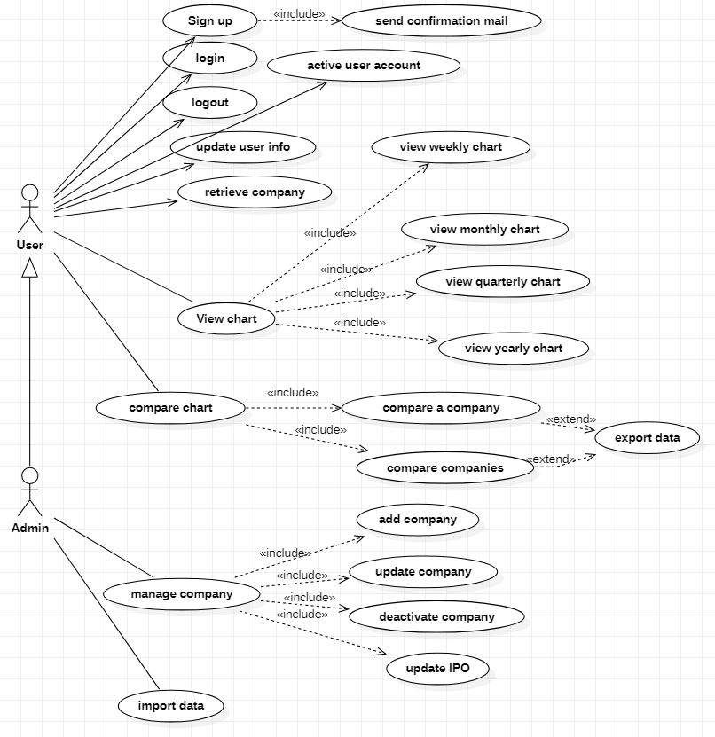

* 1. User case specification

1.2.1 sign up

|  |  |
| --- | --- |
| Case name | Sign up |
| Case Number | Case_user_001 |
| Case Brief | Create a user account |
| Case diagram |  |
| Case UI |  |
| Main Flow | 1. User input a name, password, email address, phone number. 2. User click Submit button. 3. User sees succeed page. |
| Alternative Flow | 1a, check if username exists in DB; if Yes, show message on page.  1b, check if mail address is correct; if No, show message on page.  1c, check if the passwords in two input box match; if No, show message on page. |
| Exception Flow | If any error happens, show system error page. |
| Business Rule | Username is unique. |
| Another document |  |
| Comment |  |

1.2.2 Active user

|  |  |
| --- | --- |
| Case name | Active user account |
| Case Number | Case_user_002 |
| Case Brief | Active e a user account |
| Case diagram |  |
| Case UI |  |
| Main Flow | 1. User open mail in mailbox. 2. User click confirmation link. 3. User get success page. |
| Alternative Flow |
| Exception Flow | If any error happens, show system error page. |
| Business Rule | Precondition: user’s status is not active. |
| Another document |  |
| Comment |  |

……………….

1. Business flow
2. Database Design

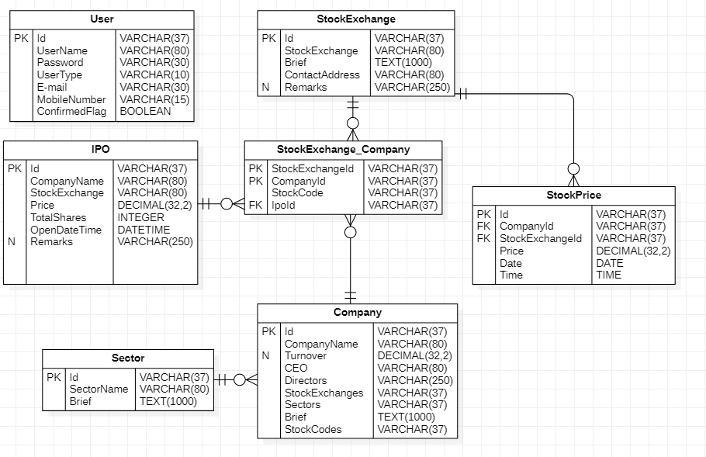

1. System architecture